Monitoring biodiversity for human, animal, plant and environmental health
Francis Banville
Colin Carlson
Elodie Eiffener
Gabriel Munoz Acevedo
Andrea Paz Velez
Timothée Poisot
2026-04-13
Abstract
The One Health approach promotes collaboration across disciplines to enhance the health of humans, animals, plants, and the environment. The Quadripartite organizations, which include the Food and Agriculture Organization of the United Nations, the United Nations Environment Programme, the World Organisation for Animal Health, and the World Health Organization, developed the One Health Joint Plan of Action (OH JPA) to support countries in achieving One Health. This plan consists of six action tracks, each consisting of a set of actions for implementing One Health. By requiring knowledge on zoonotic diseases (tracks 2 and 3), food and agriculture (track 4), antimicrobial resistance (track 5), and environmental health (track 6), most of these tracks directly concern biodiversity. However, there are currently no indicators for monitoring the OH JPA. Our research examines the extent to which all six tracks are covered by the Kunming-Montreal Global Biodiversity Framework (KM-GBF) monitoring framework of the Convention on Biological Diversity (CBD), which contains many indicators at the intersection of biodiversity and Health. We assessed (1) the link between each indicator of the KM-GBF monitoring framework and human, animal, plant, and environmental health and (2) the usability of these indicators for monitoring One Health actions. We found that 75% of indicators are associated with Health, and that 91% of indicators can be used for monitoring One Health actions. Overall, our work aims to strengthen collaboration between the CBD Secretariat and the Quadripartite Organizations by highlighting the need for shared data, policy, and governance practices.

Introduction
Human health responds to changes in biodiversity in complex and sometimes opposite ways (Robinson et al., 2024). On one hand, through nature’s contributions to people, biodiversity provides shelter and food that are vital to human health (Diaz et al., 2018). On the other hand, infectious diseases originating in wildlife can be a major threat to public health (Jones et al., 2008). The health of animals, plants, and the wider environment greatly impacts the capacity of ecosystems to provide services and prevent disease emergence (Rabinowitz & Conti, 2013). Moreover, the relationship between biodiversity and health becomes far more important when we consider that they are both affected by the same threats (e.g., climate and land use change, Carlson et al., 2025), supported by the same actions that mitigate these threats, and monitored by the same set of tools (Poisot et al., 2025). The One Health approach (Danasekaran, 2024) recognizes these interconnections between human, animal, plant, and environmental health and provides a set of principles for achieving a healthier planet by fostering collaboration across disciplines.
The One Health Joint Plan of Action (OH JPA, Quadripartite organizations, 2022) is an action-oriented framework aimed at advancing One Health principles in the horizon of 2026. Developed by the Quadripartite collaboration, which is a strategic One Health partnership between the Food and Agriculture Organization of the United Nations (FAO), the United Nations Environment Programme (UNEP), the World Organisation for Animal Health (WOAH), and the World Health Organization (WHO), the OH JPA contains 19 actions that address important challenges at the interface between human, animal, plant, and environmental health. These actions form six action tracks that collectively seek to strengthen health systems and food safety capacities while preventing zoonotic diseases, antimicrobial resistance, and environmental degradation. However, while this plan does a good job at promoting capacity-building across many dimensions of One Health, there are currently no indicators that would help us monitor its implementation. As we enter the final year of the plan, the need to evaluate the progress made since its adoption in 2022 grows acute, especially as this evaluation can inform the development of the next version of the plan.
In 2022, in their fifteenth conference, the Parties to the Convention of Biological Diversity (CBD) adopted the Kunming-Montreal Global Biodiversity Framework (KM-GBF, UNEP, 2022) to halt and reverse biodiversity loss by 2030. To achieve this, the KM-GBF contains 4 general goals and 23 specific targets, ranging from the restoration of degraded ecosystems to the integration of biodiversity in decision-making. The KM-GBF monitoring framework (UNEP, 2025) includes 204 indicators that countries can use to monitor these goals and targets. These indicators are classified in four groups: headline (high-level), binary (yes/no questions), component (technical), and complementary (supporting) indicators. Two of these groups (headline and binary indicators) are mandatory, i.e. countries have the legal obligation to include them in their national reports. Measuring these indicators requires significant resources and expertise, which should therefore be well allocated.
More recently, the Parties to the CBD also adopted the Global Action Plan on Biodiversity and Health (GAP-BH), which formally recognizes the links between biodiversity and Health (UNEP, 2024). The GAP-BH groups the targets of the KM-GBF into 14 thematic categories, ranging from Access and Benefit-Sharing (category 9) to Knowledge and Engagement of People (category 14). Each thematic category has its own relevance to Health. For example, the targets that fall under the Mainstreaming category contribute to “the consideration of biodiversity and health interlinkages in decision-making across all sectors [which] can improve awareness of the benefits of biodiversity to foster more equitable health systems” (UNEP, 2024). Because of the high relevance of KM-GBF targets to Health, we hypothesized that a large proportion of the indicators of these targets will also be relevant to Health.
This study aims to identify the indicators of the KM-GBF monitoring framework that are of relevance to One Health. First, we assessed the link between each of these indicators and human, animal, plant, and environmental health. We found that 75% of indicators are directly or indirectly connected to at least one of the four pillars of One Health. This result reinforces the need for collaboration between biologists, who are experts of these indicators, and health professionals, who need information at the intersection of biodiversity and Health. Second, we evaluated the usability of the KM-GBF indicators for monitoring the specific actions of the OH JPA. We found that 91% of indicators can be used, either directly or after adaptation, to monitor actions in at least one action track. Reusing indicators can greatly reduce the workload of countries and their need to develop and monitor new indicators at the intersection of human, animal, plant, and environmental health. Together, these two results highlight the need for data sharing and knowledge transfer practices between the CBD Secretariat and the Quadripartite organizations. More importantly, our results emphasize that biodiversity is an essential component of effective One Health strategies, and that adequate biodiversity monitoring enables tracking the progress towards the ambitious goals of the OH JPA.

Methods
We qualitatively assessed the relevance of all 204 KM-GBF indicators (UNEP, 2025) to Health. Specifically, we evaluated the degree to which they are linked to each of the four pillars of One Health (i.e., to human, animal, plant, and environmental heath), as well as their usability for monitoring the OH JPA. Our assessments were informed by the metadata (rationale, definition, method of computation, data sources, and scale of use) of the indicators provided by the World Conservation Monitoring Centre of the UN Environment Programme (UNEP-WCMC, 2025), when available, looking for explicit considerations of Health. When such metadata was unavailable, assessments were based on expert elicitation. The result of this analysis and the code to reproduce the figures are available on Zenodo.

Assessing the link between indicators and Health
Assessing the link between the KM-GBF indicators and the four pillars of One Health required a working definition of human, animal, plant, and environmental health. We defined each of these groups of species based on the main objects of interest of the Quadripartite organizations. Humans are their own pillar and the primary focus of the WHO. We considered pets, livestock, and edible marine and freshwater species captured from fisheries and aquaculture in the animal health pillar. These are species mainly looked after by veterinarians and food inspectors and that are of core concern to the WOAH and FAO. Even though humans and wildlife are also animals, we excluded them from the animal health pillar. We included all cultivated plants used for food, fuel, and medicine into the plant health pillar, i.e. plant species that are the primary focus of the FAO. Wildlife was considered in the environment health pillar, alongside all other species not included in the other three pillars. The environment health pillar also includes whole ecosystems (natural and artificial), as well as tree species used in forestry and wild fish species. It is the primary focus of the UNEP. These definitions are alined with the core contributing sciences of the One Health approach (Gibbs, 2014; Lerner & Berg, 2017).
The concept of Health varies depending on the level of biological organization (Lerner & Berg, 2015). At the individual level, we used a broad definition of Health that considers the overall well-being of individuals and their capacity to function normally, which includes the absence of diseases (WHO, 1948). In humans and domestic and wildlife animals, well-being is the ability for an individual to satisfy its physical, mental, and behavioral needs (Webb et al., 2019), whereas diseases are undesirable conditions often leading to pain, suffering, or death. In plants, which are not conscious organisms (Mallatt et al., 2021), health is more ill-defined (Döring et al., 2012). Here, we considered plant health as the extent to which an individual is able to function physiologically, and plant diseases as impediments to their normal physiological functioning often leading to death. At the ecosystem level, consisting of many individuals and their interactions, health is also ill-defined (Schaeffer et al., 1988). We defined environmental health as the extent to which an ecosystem can maintain its biological and chemical processes and adapt to changes (Jakobsson, 2012). Disturbances are the ecosystem analogue of diseases, and represent degradations that usually lead to a decline in ecosystem functioning. When assessing environmental health, we also considered the health of species included in the environment pillar of One Health, e.g. wildlife and uncultivated plant species.
We classified the degree to which the indicators are linked to each of the four pillars of One Health into four categories: direct connection, indirect connection, potential connection, and no connection. An indicator was qualified as directly connected to Health when there is a direct causal relationship between the indicator and Health. This is the case when the indicator directly measures a condition or determinant of Health. For example, headline indicator 7.2 “Pesticide environment concentration and/or aggregated total applied toxicity” was considered directly connected to human health because of the toxicity of many pesticides under high level of exposure (Kim et al., 2017). Then, an indicator was qualified as indirectly connected to Health when there is an intermediary factor between the indicator and Health. For instance, component indicator 4.CT.1 “Number of plant and animal genetic resources for food and agriculture secured in either medium- or long-term conservation facilities” was considered indirectly connected to human health because conserving genetic resources increases the resilience of food systems to global disasters (Esquinas-Alcázar, 2005), which in turn protects human health. Next, an indicator was qualified as potentially connected to Health when there are multiple intermediary factors between the indicator and Health, or when its connection to Health is likely but difficult to certify. For example, complementary indicator 2.CY.2 “Proportion of key biodiversity areas in favourable condition” was qualified as potentially connected to human health because key biodiversity areas are mainly defined with ecological criteria for conserving rare or endemic species and pristine habitats (Butchart et al., 2026), and may or may not include areas of high importance for human health. Finally, an indicator was qualified as not connected to Health when the connection is unlikely, unsupported by current scientific evidence, or absent. This was the case for component indicator 21.CT.3 “Index of linguistic diversity”, for which we did not find any evidence of a link to human, animal, plant or environmental health. For each of the four pillars of One Health, we counted the number of indicators assigned to each category.

Assessing the usability of indicators for monitoring the OH JPA
We evaluated the usability of the KM-GBF indicators for monitoring the OH JPA by judging if they can likely detect trends relevant to the actions of the plan. For each action track, we classified the usability of the indicators into three categories: directly usable, usable after adaptation, and not usable. Directly usable indicators can be used in their current form to monitor at least one action in an action track. They do not require adaptations. For example, we qualified component indicator 4.CT.4 “Proportion of local breeds classified as being at risk of extinction” as being directly usable for monitoring the fourth action track because it directly measures food safety risks. In contrast, indicators usable after adaptation need to be slightly modified before they can be used to monitor actions in an action track. These adaptations should be small changes in the scale of measurement, the data resolution, or the taxa monitored by the indicator. For instance, we qualified headline indicator 9.1 “Benefits from the sustainable use of wild species” as being usable after adaptation for monitoring the second action track on zoonotic epidemics and pandemics. To be more relevant for this action track, this indicator could refer more specifically to wildlife reservoirs of zoonotic agents instead of all wild species. Finally, not usable indicators are outside the scope of an action track or need to be greatly modified before being used to monitor an action track. For example, we qualified component indicator 4.CT.3 “Human-wildlife conflict indicator” as being not usable for monitoring the fifth action track on antimicrobial resistance.
We assessed usability for each action track independently, i.e. an indicator can be useful for monitoring multiple action tracks. For each action track, we counted the total number of indicators in each category. In addition, we counted the number of usable indicators for the whole plan regardless of the action tracks. Then, we partitioned these numbers based on the group of indicator in the KM-GBF monitoring framework (i.e. headline, binary, component, and complementary indicators) and the thematic categories of the GAP-BH. Finally, for each action track where an indicator was considered usable (either directly or after adaptation), we identified the most relevant action that can be monitored by the indicator, and counted the number of indicators associated with each action.

Results and discussion

Link between indicators and Health
We found that 75% of KM-GBF indicators are either directly or indirectly connected to human, animal, plant, or environmental health, with approximately 55% of indicators being directly connected to Health. This indicates that monitoring the state, benefits, and pressure of biodiversity and our responses to biodiversity loss gives us a lot of information on One Health. In Figure 1, we show the number of indicators that are directly, indirectly, potentially, and not connected to each of the four pillars of One Health. The number of directly connected indicators is slightly higher for environmental health (41% of indicators) compared to human (27%), animal (26%), and plant (28%) health. However, this difference shrinks after adding indirectly connected indicators (63% for environmental health compared to 56%, 53%, and 51% respectively for human, animal, and plant health). This suggests that the four pillars of One Health can all be meaningfully informed by biodiversity monitoring.
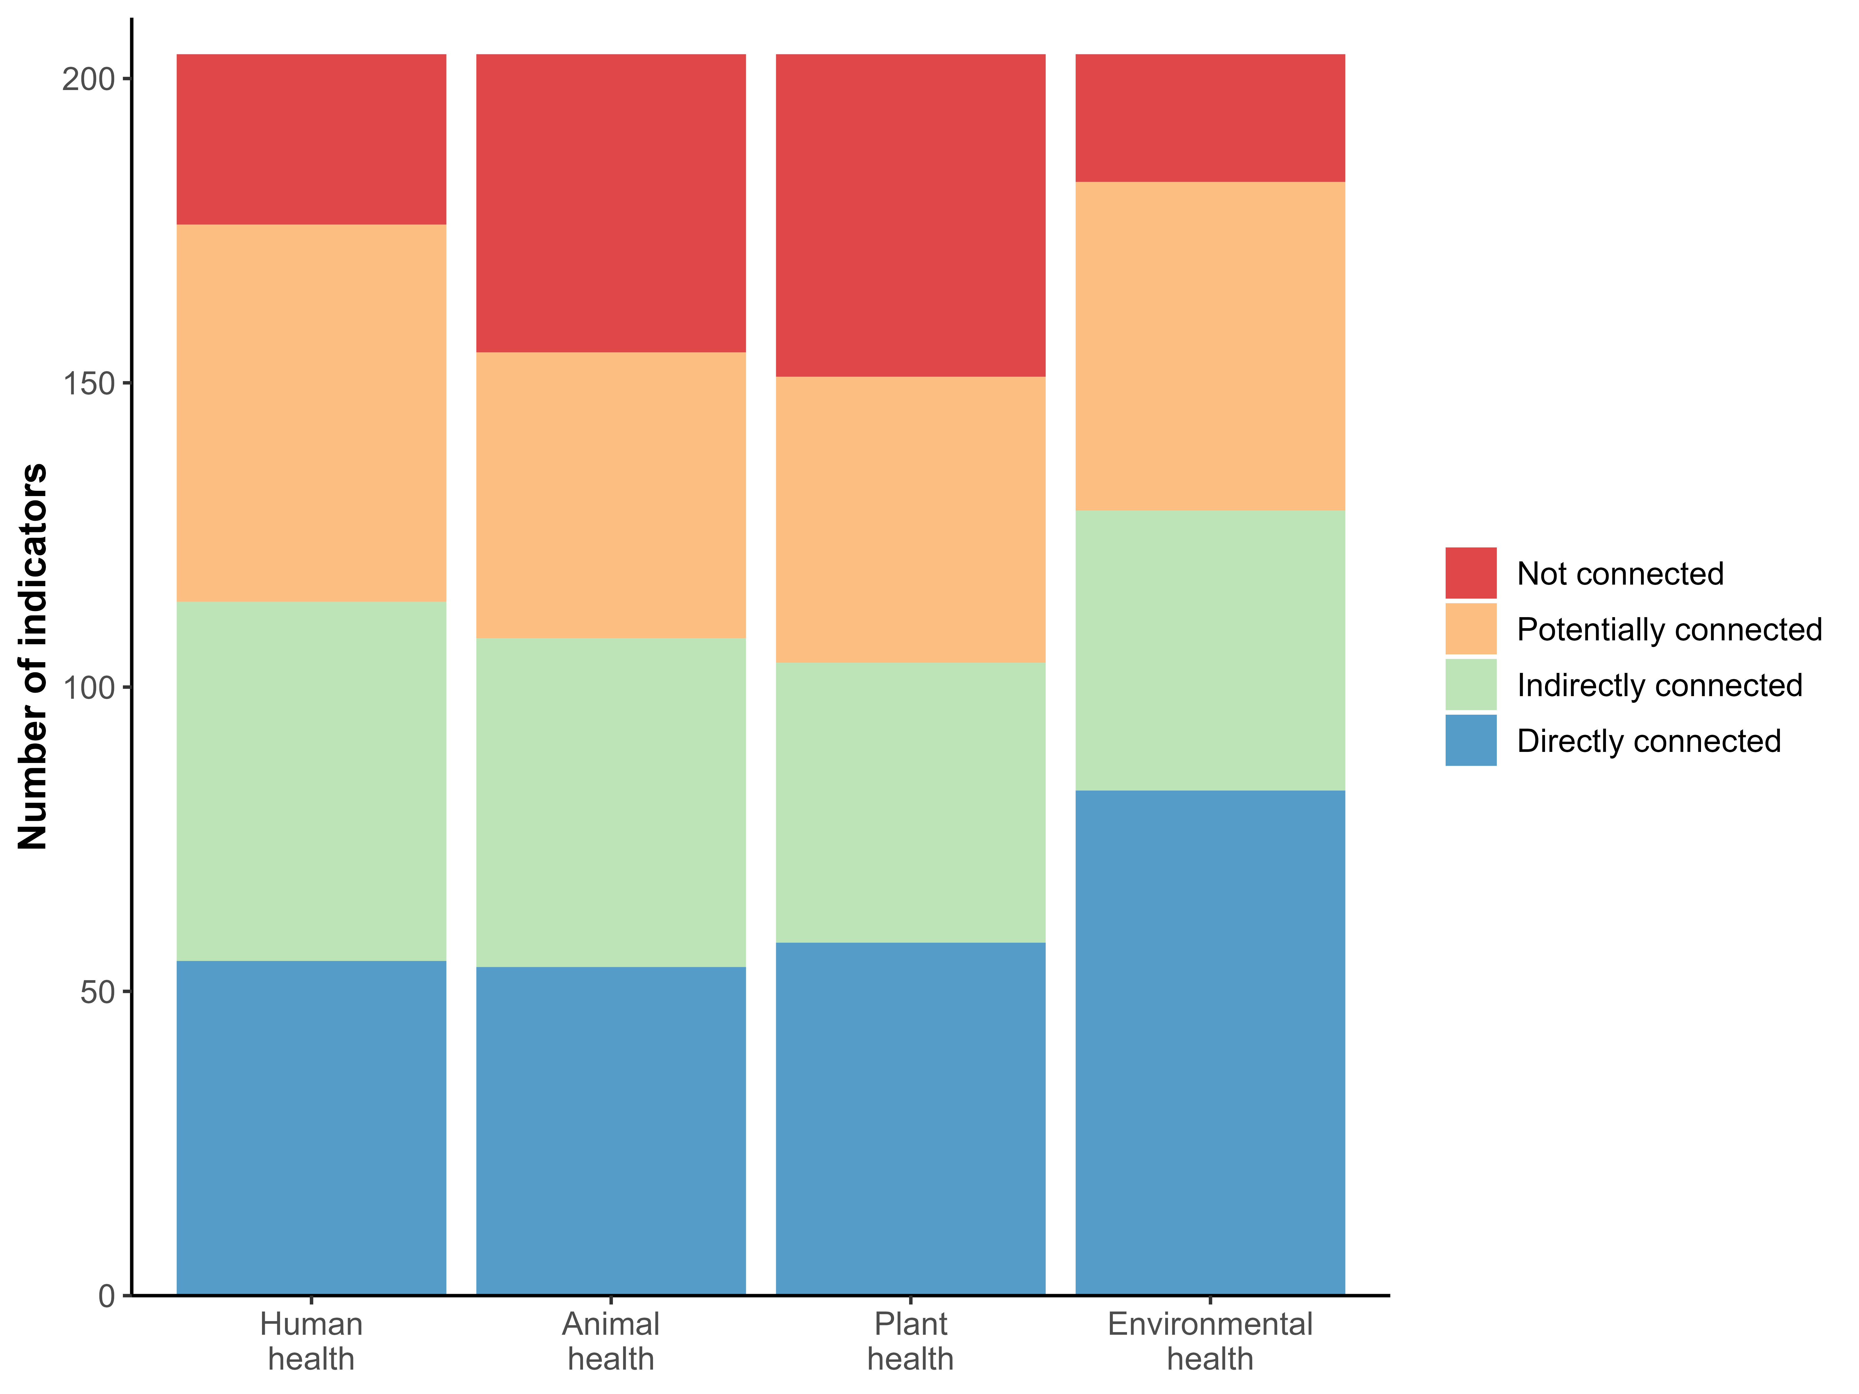
Figure 1: Number of KM-GBF indicators linked with human, animal, plant, and environmental health. Each indicator was classified as being either directly connected (blue), indirectly connected (green), potentially connected (orange), or not connected (red) to each of the four pillars of One Health.
The fact that most KM-GBF indicators are connected to Health is not surprising. The GAP-BH recognizes the relevance to Health of all 23 targets of the KM-GBF, and because the indicators measure the progress made towards these targets, they also measure the progress made towards a healthier planet. However, we did not expect that comparable amounts of indicators would monitor the four pillars of One Health. This indicates that there are virtually no biases in the amount of information that can be reused to monitor human, animal, plant, and environmental health. In other words, we monitor all core components of One Health when we monitor biodiversity.

Usability of indicators for monitoring the OH JPA
The vast majority of KM-GBF indicators (91%) can be used either directly or after adaptation to monitor actions in the OH JPA, and around 74% of indicators can be used directly. This signifies that we can already do an extensive evaluation of One Health actions with existing data and methodologies. However, we show in Figure 2 that the usability of indicators greatly differs depending on the action track. The proportion of usable indicators varies from 20% for the fifth action track on antimicrobial resistance (4% of directly usable indicators) to 79% for the sixth action track on the integration of the environment into One Health (62% of directly usable indicators). The high proportion of usable indicators for the sixth action track is not surprising given that the KM-GBF is a multilateral environmental agreement that aims to protect species and restore ecosystems. The low proportion of indicators that can monitor actions in the fifth action track could be due to the characteristics of these actions, which are more focused on collaboration, capacity-building and awareness-raising than the decrease and prevention of antimicrobial resistance through biodiversity. Similarly, the actions in the third action track on endemic zoonotic, neglected tropical, and vector-borne diseases, which can only be monitored by 33% of the indicators, are more centered on capacity-building and less on the drivers and inhibitors of infectious diseases, especially in comparison to the actions of the second action track on zoonotic epidemics and pandemics. These differences suggest that, although the KM-GBF monitoring framework can greatly reduce the workload of countries by reducing the need to develop new indicators at the intersection of biodiversity and Health, additional work is still needed to equally cover all aspects of the plan.
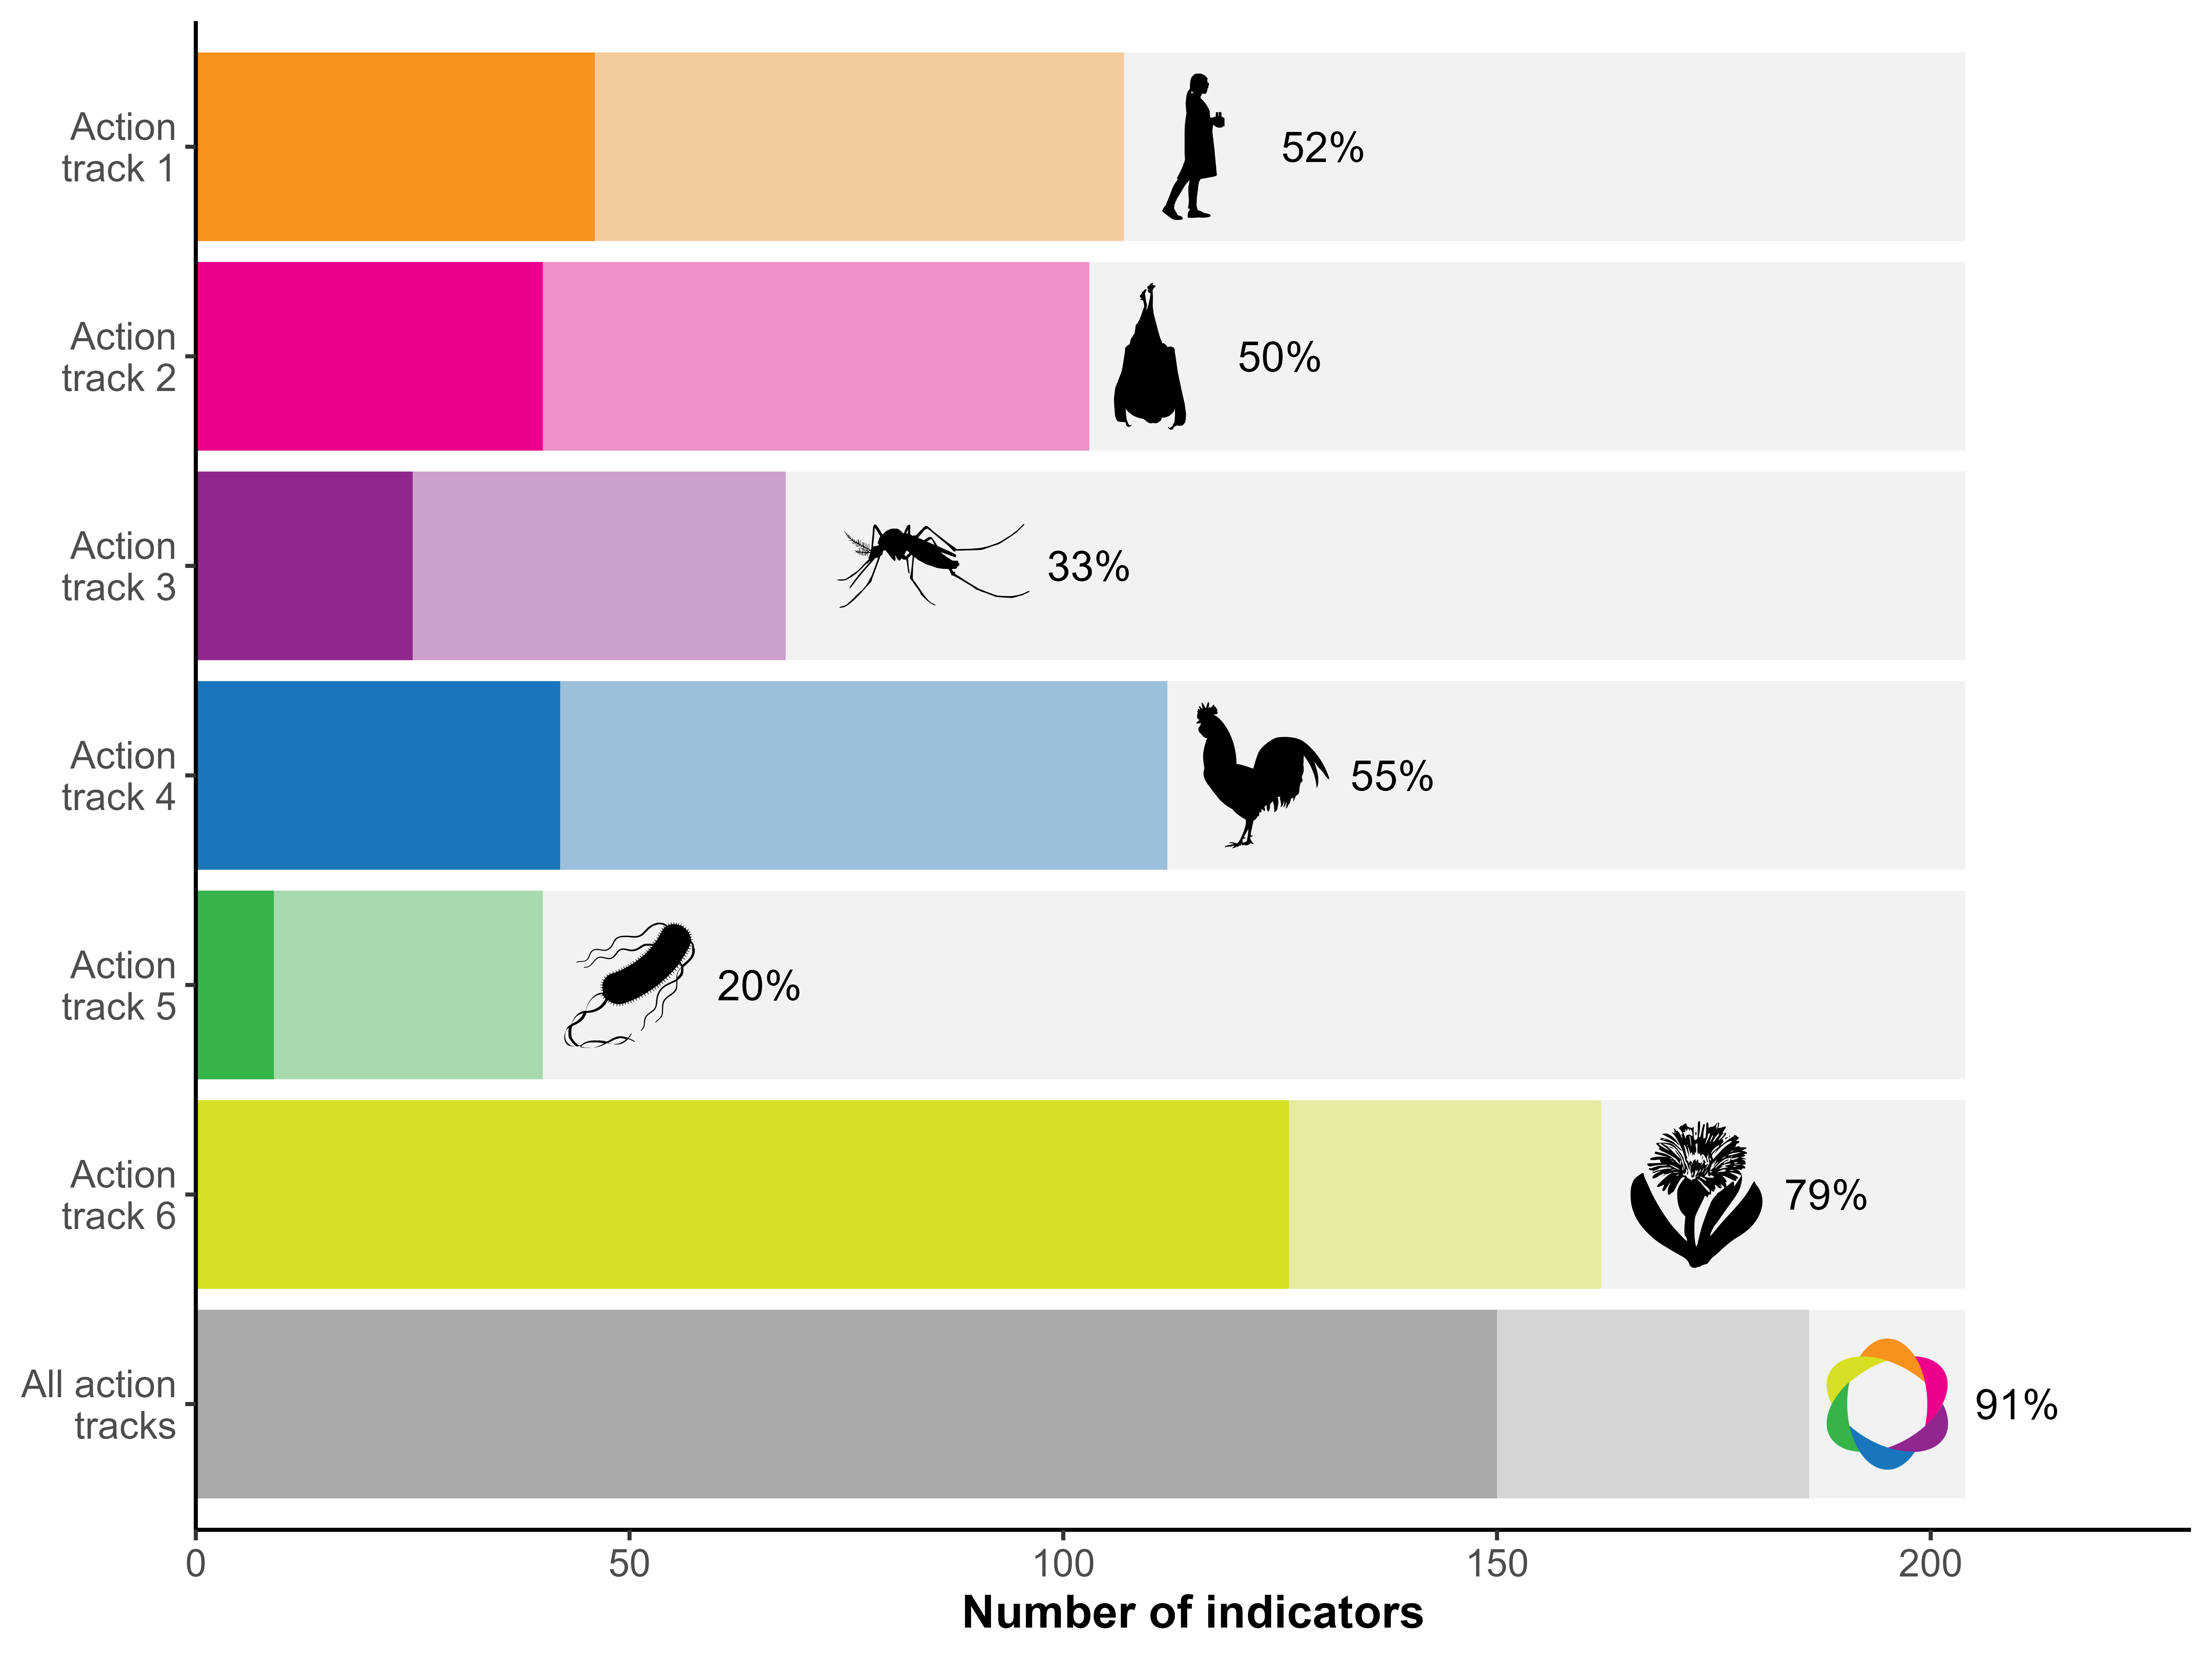
Figure 2: Number of KM-GBF indicators that can be used to monitor at least one action in each of the OH JPA action tracks. The opaque bars represent directly usable indicators, whereas the transparent bars represent those usable after adaptation. The proportion of usable indicators (either directly or after adaptation) for each action track is indicated. The bottom bar and proportion designate the indicators that can monitor at least one action in the whole plan.
The number of indicators associated with each action is presented in Table 1. There are high discrepancies in the usability of indicators between actions. The total number of usable indicators (either directly or after adaptation) varies from 1 (action 5.3: Strengthen global AMR governance structures) to 108 (action 6.1: Protect, restore, and prevent the degradation of ecosystems and the wider environment). Within a single action track, the biggest differences are found within the sixth action track, where only 12 indicators were associated to action 6.4 whereas 108 indicators were associated to action 6.1 This result shows that there is substantial information available for some of the actions, but it also further highlights the need to identify or develop new indicators for specific actions of the plan, even within the action tracks that can be monitored by numerous indicators.
Table 1: Number of KM-GBF indicators that can be used directly and after adaptation to monitor each action of the OH JPA. The total number of usable indicators for each action track is indicated in the highlighted blue lines. A specific indicator can be used to monitor multiple action tracks, but only the most relevant action in each action track was identified for each indicator.
Action | Directly usable | Usable after adaptation | Total usable
1 Enhancing One Health capacities to strengthen health systems | 46 | 61 | 107
1.1 Establish the foundations for One Health capacities | 30 | 5 | 35
1.2 Generate mechanisms, tools, and capacities to establish a One Health competent workforce and the frameworks/processes to facilitate One Health work | 8 | 50 | 58
1.3 Generate an enabling environment for the effective implementation of One Health | 8 | 6 | 14
2 Reducing the risks from emerging and re-emerging zoonotic epidemics and pandemics | 40 | 63 | 103
2.1 Understand the drivers of emergence, spillover, and spread of zoonotic pathogens | 16 | 27 | 43
2.2 Identify and prioritize targeted, evidence-based upstream interventions to prevent the emergence, spillover, and spread of zoonotic pathogens | 7 | 6 | 13
2.3 Strengthen national, regional, and global One Health surveillance, early warning, and response systems | 17 | 30 | 47
3 Controlling and eliminating endemic zoonotic, neglected tropical and vector-borne diseases | 25 | 43 | 68
3.1 Enable countries to develop and implement community-centric and risk-based solutions to endemic zoonotic, neglected tropical, and vector-borne disease control using a One Health approach involving all relevant stakeholders | 3 | 14 | 17
3.2 Ensure the harmonized application of One Health principles at all levels by implementing practical measures to strengthen local, national, regional, and global policy frameworks for the control and prevention of endemic zoonotic, neglected tropical, and vector-borne diseases | 18 | 10 | 28
3.3 Increase political commitment and investment in the control of endemic zoonotic, neglected tropical, and vector-borne diseases, by advocating for and demonstrating the value of a One Health approach | 4 | 19 | 23
4 Strengthening the assessment, management and communication of food safety risks | 42 | 70 | 112
4.1 Strengthen the One Health approach in national food control systems and food safety coordination | 18 | 30 | 48
4.2 Utilize and improve food systems data and analysis, scientific evidence, and risk assessment in developing policy and making integrated risk management decisions | 15 | 21 | 36
4.3 Foster the adoption of the One Health approach in national foodborne disease surveillance systems and research for the detection and monitoring of foodborne disease and food contamination | 9 | 19 | 28
5 Curbing the silent pandemic of antimicrobial resistance (AMR) | 9 | 31 | 40
5.1 Strengthen the capacity and knowledge of countries to prioritize and implement context-specific collaborative One Health work to control AMR in policy, legislation, and practice | 7 | 17 | 24
5.2 Reinforce global and regional initiatives and programmes to influence and support One Health responses to AMR | 2 | 13 | 15
5.3 Strengthen global AMR governance structures | 0 | 1 | 1
6 Integrating the environment into One Health | 126 | 36 | 162
6.1 Protect, restore, and prevent the degradation of ecosystems and the wider environment | 92 | 16 | 108
6.2 Mainstream the health of the environment and ecosystems into the One Health approach | 9 | 7 | 16
6.3 Integrate environmental knowledge, data, and evidence into One Health decision-making | 20 | 6 | 26
6.4 Create an interoperable One Health academic and in-service training programme for environmental, medical, agricultural, and veterinary sector professionals | 5 | 7 | 12

Figure 3 shows the proportion of indicators that can be used to monitor each action track, for each group of indicators in the KM-GBF monitoring framework. We evaluated that 100% of headline indicators (27/27), 93% of binary indicators (14/15), 94% of component indicators (49/52), and 87% of complementary indicators (96/110) can be used, either directly or after adaptation, to monitor at least one action track. Headline and binary indicators are the only two groups of indicators that are mandatory, i.e. that Parties have the legal obligation to report on. The high proportion of headline and binary indicators is encouraging, because it indicates that the information most likely to figure in National Biodiversity Strategies and Action Plans (NBSAPs) will be reusable for evaluating the implementation of the OH JPA. On the other hand, the high reusability of component and complementary indicators, which are currently optional, should be seen as an additional incitative to measure them.
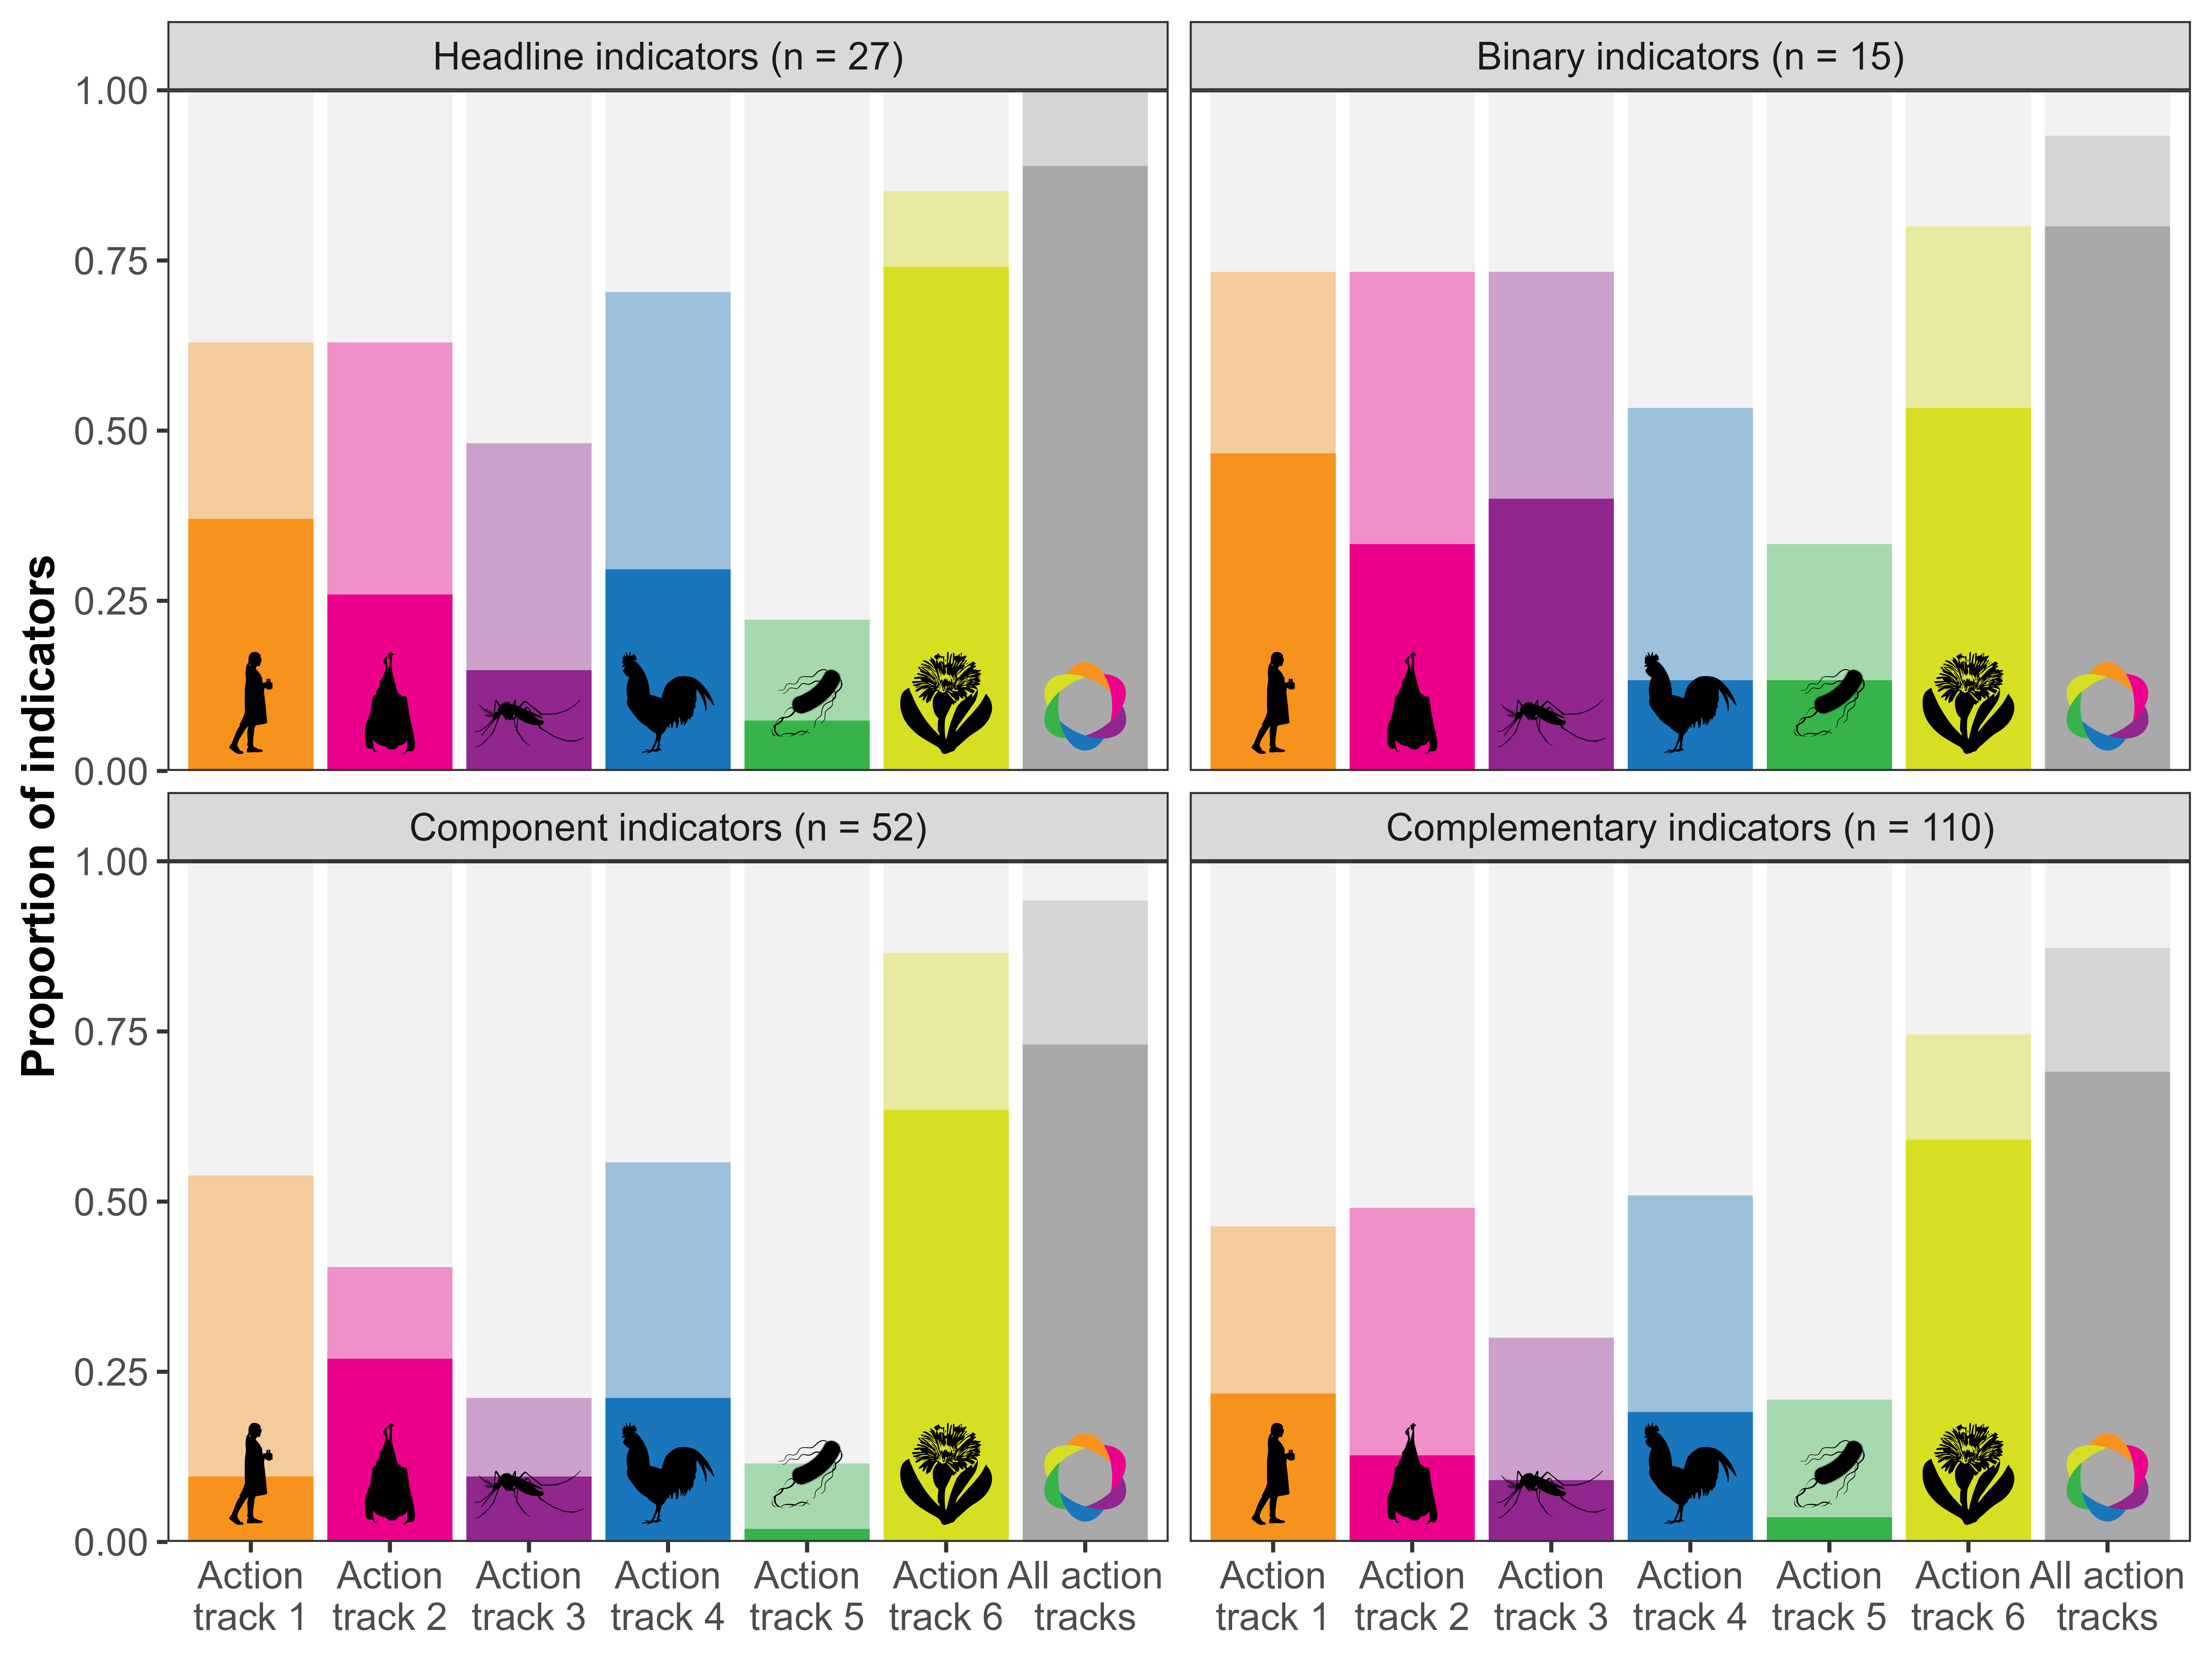
Figure 3: Proportion of KM-GBF indicators that can be used to monitor at least one action in each of the OH JPA action tracks, partitioned by the different groups of indicators. The number of indicators in each group is indicated in parentheses. The opaque bars represent directly usable indicators, whereas the transparent bars represent those usable after adaptation. The gray bars designate the indicators that can monitor at least one action in the whole plan.
In Figure 4, we present the usability of indicators for each thematic category of the GAP-BH. In every category, at least 89% of indicators can be used, either directly or after adaptation, for monitoring at least one action track, excepting in the Knowledge and engagement of people category, which only has 52% of usable indicators. This suggests that every sector of the KM-GBF monitoring framework, from Nature’s contribution to people to Species management, is relevant for One Health, even though there are wide variations in the action track most relevant for each category. This figure also shows that all indicators that can directly monitor the fifth action track on antimicrobial resistance are in the Access and benefit-sharing and Biosafety and biotechnology categories, further emphasizing the importance of collaboration, capacity-building and awareness-raising set forth in this action track.
Figure 4: Proportion of KM-GBF indicators that can be used to monitor at least one action in each of the OH JPA action tracks, partitioned by the different thematic categories of the GAP-BH. The number of indicators in each thematic category is indicated in parentheses. The thematic category of an indicator was assigned based on the thematic category of its target. Indicators that monitor KM-GBF goals A, B, C, and D are not assigned to any thematic category. The opaque bars represent directly usable indicators, whereas the transparent bars represent those usable after adaptation. The gray bars designate the indicators that can monitor at least one action in the whole plan.

Conclusion
Reusing existing indicators can greatly reduce the workload of countries that are part of different multilateral environmental agreements with overlapping objectives. Instead of developing new indicators, our study shows that countries can reuse many indicators from the KM-GBF monitoring framework to monitor One Health actions. Our evaluation suggests that most of these indicators are linked to Health and can be used to monitor the specific actions of the OH JPA. Biologists, who develop and measure these indicators, can thus meaningfully contribute to One Health efforts by sharing their data, methodologies, and expertise with the health sector. However, additional work is needed to identify or develop new indicators for the action tracks where few indicators were found to be usable. These gaps could be filled by finding existing indicators at the intersection of human, animal, plant, and environmental health in other multilateral environmental agreements (e.g. the indicators of the Sustainable Development Goals). Nevertheless, the high reusability of most KM-GBF indicators for monitoring One Health actions underlines the need for close collaboration between the CBD Secretariat and the Quadripartite organizations, especially as we enter the last year of the One Health Joint Plan of Action.

Acknowledgments
We acknowledge that this study was conducted on land within the traditional unceded territory of the Saint Lawrence Iroquoian, Anishinabewaki, Mohawk, Huron-Wendat and Omàmiwininiwak nations. TP was funded through award no. 223764/Z/21/Z from the Wellcome Trust and supported by the US National Science Foundation (grant no. DBI 2213854). We thank members of the GEO BON One Health working group and Claire Burnel for their useful feedback on the manuscript.

References
Butchart, S. H. M., Crowe, O., Scott, T., Plumptre, A. J., Eldred, M., McKee, E., Waliczky, Z., Hasani, I. A., Azpiroz, A. B., Baisero, D., Barasa, F., Beresford, A. E., Bezeng, B. S., Boyd, C., Brooks, T. M., Buchanan, G., Bunting, G., Capellan, S., Cox, N., … Upgren, A. (2026). Extent, characteristics and policy applications of Key Biodiversity Areas. Biological Reviews of the Cambridge Philosophical Society. https://doi.org/10.1002/brv.70144
Carlson, C. J., Brookson, C. B., Becker, D. J., Cummings, C. A., Gibb, R., Halliday, F. W., Heckley, A. M., Huang, Z. Y. X., Lavelle, T., Robertson, H., Vicente-Santos, A., Weets, C. M., & Poisot, T. (2025). Pathogens and planetary change. Nature Reviews Biodiversity, 1(1), 32–49. https://doi.org/10.1038/s44358-024-00005-w
Danasekaran, R. (2024). One Health: A Holistic Approach to Tackling Global Health Issues. Indian Journal of Community Medicine: Official Publication of Indian Association of Preventive & Social Medicine, 49(2), 260–263. https://doi.org/10.4103/ijcm.ijcm_521_23
Diaz, S., Pascual, U., Stenseke, M., Martin-Lopez, B., Watson, R. T., Molnar, Z., Hill, R., Chan, K. M. A., Baste, I. A., Brauman, K. A., Polasky, S., Church, A., Lonsdale, M., Larigauderie, A., Leadley, P. W., van Oudenhoven, A. P. E., van der Plaat, F., Schroter, M., Lavorel, S., … Shirayama, Y. (2018). Assessing nature’s contributions to people. Science, 359(6373), 270–272. https://doi.org/10.1126/science.aap8826
Döring, T. F., Pautasso, M., Finckh, M. R., & Wolfe, M. S. (2012). Concepts of plant health – reviewing and challenging the foundations of plant protection. Plant Pathology, 61(1), 1–15. https://doi.org/10.1111/j.1365-3059.2011.02501.x
Esquinas-Alcázar, J. (2005). Protecting crop genetic diversity for food security: Political, ethical and technical challenges. Nature Reviews Genetics, 6(12), 946–953. https://doi.org/10.1038/nrg1729
Gibbs, E. P. J. (2014). The evolution of One Health: A decade of progress and challenges for the future. Veterinary Record, 174(4), 85–91. https://doi.org/10.1136/vr.g143
Jakobsson, C. (2012). Sustainable Agriculture. Baltic University Press.
Jones, K. E., Patel, N. G., Levy, M. A., Storeygard, A., Balk, D., Gittleman, J. L., & Daszak, P. (2008). Global trends in emerging infectious diseases. Nature, 451(7181), 990–U4. https://doi.org/10.1038/nature06536
Kim, K.-H., Kabir, E., & Jahan, S. A. (2017). Exposure to pesticides and the associated human health effects. Science of The Total Environment, 575, 525–535. https://doi.org/10.1016/j.scitotenv.2016.09.009
Lerner, H., & Berg, C. (2015). The concept of health in One Health and some practical implications for research and education: What is One Health? Infection Ecology & Epidemiology, 5(1), 25300. https://doi.org/10.3402/iee.v5.25300
Lerner, H., & Berg, C. (2017). A Comparison of Three Holistic Approaches to Health: One Health, EcoHealth, and Planetary Health. Frontiers in Veterinary Science, 4, 163. https://doi.org/10.3389/fvets.2017.00163
Mallatt, J., Blatt, M. R., Draguhn, A., Robinson, D. G., & Taiz, L. (2021). Debunking a myth: Plant consciousness. Protoplasma, 258(3), 459–476. https://doi.org/10.1007/s00709-020-01579-w
Poisot, T., Becker, D. J., Catchen, M. D., Gibb, R., Shimabukuro, P. H. F., & Carlson, C. J. (2025). Biodiversity science and biosurveillance are fellow travelers. BioScience, biaf091. https://doi.org/10.1093/biosci/biaf091
Quadripartite organizations. (2022). One Health Joint Plan of Action (2022-2026): Working together for the health of humans, animals, plants and the environment. World Health Organization.
Rabinowitz, P., & Conti, L. (2013). Links among human health, animal health, and ecosystem health. Annual Review of Public Health, 34, 189–204. https://doi.org/10.1146/annurev-publhealth-031912-114426
Robinson, J. M., Breed, A. C., Camargo, A., Redvers, N., & Breed, M. F. (2024). Biodiversity and human health: A scoping review and examples of underrepresented linkages. Environmental Research, 246, 118115. https://doi.org/10.1016/j.envres.2024.118115
Schaeffer, D. J., Herricks, E. E., & Kerster, H. W. (1988). Ecosystem health: I. Measuring ecosystem health. Environmental Management, 12(4), 445–455. https://doi.org/10.1007/BF01873258
UNEP. (2022). Kunming-Montreal Global Biodiversity Framework. United Nations Environment Programme. Decision no. CBD/COP/DEC/15/4.
UNEP. (2024). Global Action Plan on Biodiversity and Health. United Nations Environment Programme. Decision no. CBD/COP/DEC/16/19.
UNEP. (2025). Monitoring framework for the Kunming-Montreal Global Biodiversity Framework. United Nations Environment Programme. Decision no. CBD/COP/16/L.26/Rev.1.
UNEP-WCMC. (2025). Indicators for the Kunming – Montreal Global Biodiversity Framework. In Indicator Repository. https://www.gbf-indicators.org/.
Webb, L. E., Veenhoven, R., Harfeld, J. L., & Jensen, M. B. (2019). What is animal happiness? Annals of the New York Academy of Sciences, 1438(1), 62–76. https://doi.org/10.1111/nyas.13983
WHO. (1948). Preamble to the Constitution of the World Health Organization as adopted by the International Health Conference. New York, 19-22 June, 1946; signed on 22 July 1946 by the representatives of 61 States (Official Records of the World Health Organization, no. 2, p. 100) and entered into force on 7 April 1948. In Constitution of the World Health Organization.

